Cumulative Journal

Sylvia Le

Connecticut College

The name of the course can pretty much describe what it will embrace – the study of how the computer works. The textbook used for the course, ‘Structured Computer Organization’ suggests the approach type of structuring computer series abstractions, each building on one below it. Using this approach, we can get the best of both worlds, reaching the desired level of complexity while still making sure that the machine is designed in an organized manner

We first began with a general talk about how computers can understand what is written by a human programmer. It’s obvious that what is convenient for humans and what is convenient for computers is greatly different; therefore, if we assume human-convenient language L1 and machine language L0, for the computer to understand, L1 must either be translated or interpreted into L0. This idea lead to the invention of a series of language, the higher one is more convenient for human readers than the lower one until a suitable language is achieved. Each language uses its predecessor as a basis. Thus, the computer can be considered a series of layers or levels, one on top of another. Most modern computers consist of 2 or more level, goes on to 6 level: digital logic level, microarchitecture level, instruction set architecture level, OS level, assembly language level, problem-oriented level. This division helps the programmer in such a way that they need not be aware of the underlying interpretation and translation while programming in n-level language. For this particular section, we also learned how to calculate the program execution time given the number of instructions equivalent to one instruction of the level above.

We next moved on to examine the evolution of multilevel machine. It’s worth pointing out that hardware and software are logically equivalent, which means that any software operation can be built directly into the hardware, any hardware instruction can also be simulated in software. We also looked at the famous observational law that predicts technological progresses – Moore’s law. Moore’s law states that the number of transistors on a chip will double every two years (or 18 months, depends on convention). Certain factors might make it harder to achieve the goals set out by Moore’s law, but manufacturers have cleverly come up with ways to resolve it.

In chapter 2, we examined the organization of the basic components that make up digital computers. A modern digital computer consists of a Central Processing Unit (CPU), memories, and I/O devices. The CPU is the brain of the computer, which function is mainly executing program from memories by fetching instruction, examine them then execute them one by one. It consists of several components that are connected by the bus. The control unit fetches instructions from the main memory and determining their type. The Arithmetic Logic Unit (ALU) performs arithmetic and Boolean algebra calculations. Cache is a small, high-speed memory used to store temporary results and certain control information. Program Counter (PC) points to the next instruction to be fetched for execution. Instruction Register (IR) holds the instructions currently being executed

The data path is introduced. It’s the heart of the CPU, and building up to this data path will be the final goal. The simple data path we first discussed in the figure below, consists of 1 to 32 registers, the ALU, and buses that connect the components. The processes of this data path is as follow: first two input is fed into the ALU input registers (A and B). These registers hold the values while the ALU is busy on other tasks. Afterward, when there is a clock signal, the values are fed to the ALU, which will perform simple operations on them. The yielded result will then be on the output register. The output register’s value can be stored back into a register. Later, the register can be written to memory. In a nutshell, it’s the process of running two operands through the ALU and storing the result. The faster the data path cycle the faster the machine runs. Most modern computers have multiple ALUs operating in parallel and specialized. In this section, we also examined and calculated some properties of the data path, in terms of execution rate, clock time, and processor bandwidth. This data path will be extended and added details to be used in the Mic-1 microprocessor as we reach chapter 4.

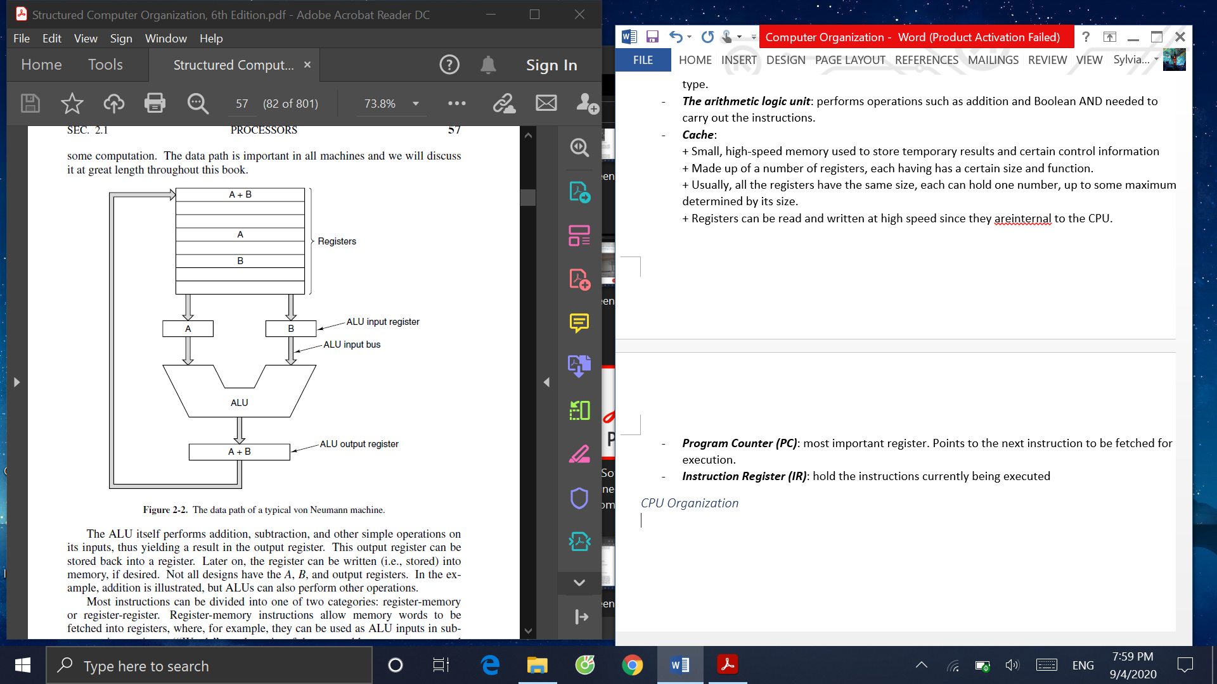

Instructions are executed in a series of small steps called the fetch-decode-execute cycle. All the steps are kept in sync by the ***system clock*** – uniform signal, unchanged, of up and down, which tells each part when to do what they are supposed to do. The frequency is how fast the instruction can be executed

A lot of time can be wasted why waiting if the CPU just wait for only the ALU and leave other components not doing anything. To avoid unused time, parallelism is used; here we examined instruction-level parallelism. The first technique, pipelining is the idea of dividing the execution of the instructions into many parts, each one handled by a different piece of hardware, all of which can run parallel. The figure below describes the process. Considering two instructions I1 and I2. When I1 is fetched in the first stage S1, and move on to be decoded in S2, the piece of hardware that is responsible for S1 can move on to fetch instruction I2. This ensures that there is no time lost on waiting for other processes, thus help to increase the bandwidth of the machine

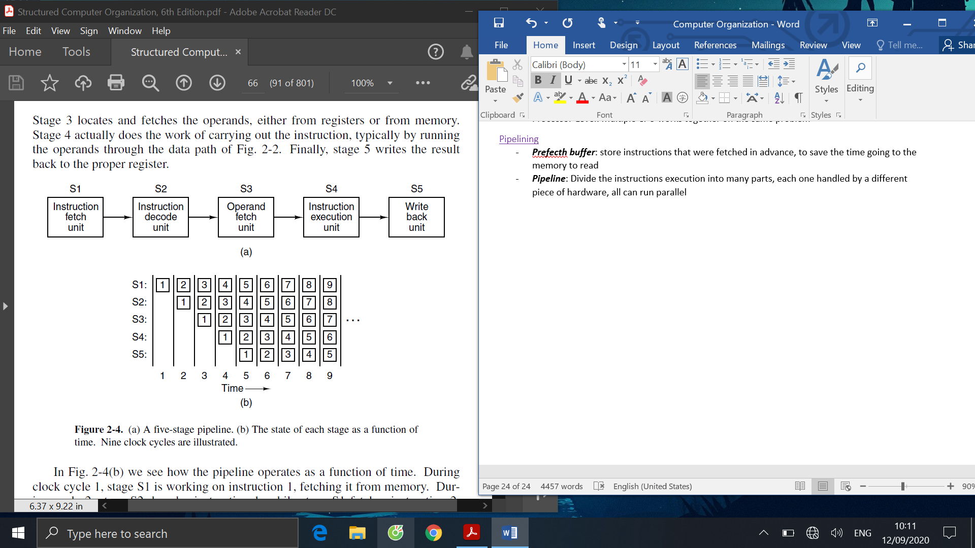

More pipelines is not necessarily make things faster, as there will be too much duplication. Superscalar is used as an alternative approach, where there is only a single pipeline, but there are multiple functional units. The superscalar structure with five functional units is described in the figure. The term is now used to describe processors that issue multiple instructions, typically 4 to 6, per single clock cycle.

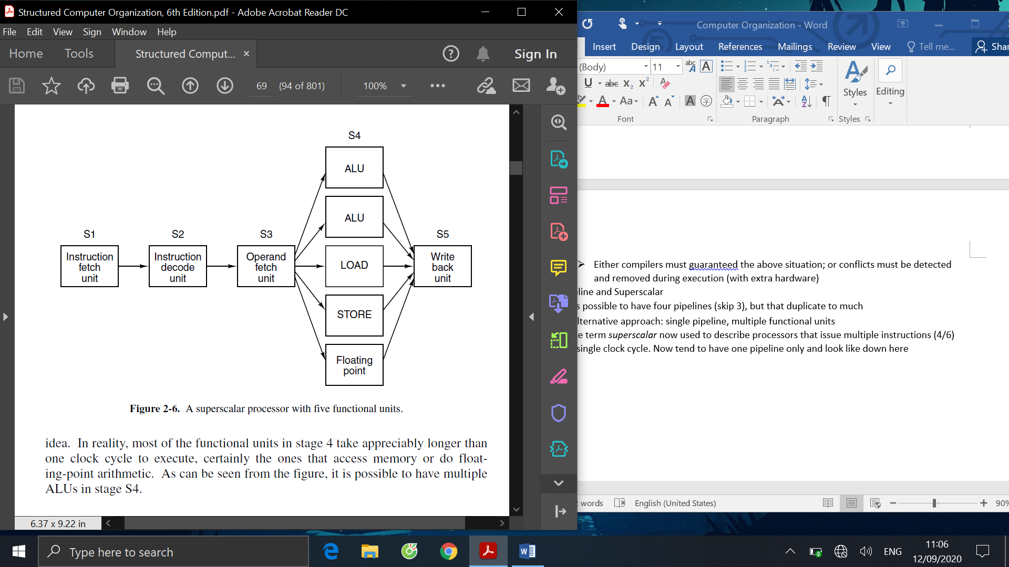

Next in the chapter, we discussed the primary memory. Before getting into memory, we looked at how computers represent data. Though it’s common knowledge that it’s through 0s and 1s, there are several conventions: pure binary code, two’s complement, sign-magnitude, excess-x, binary coded, hexadecimal. We also learned how to perform basic operations such as addition, subtraction, and converting between conventions. Finally, we learned the IEEE 754 standard used to represent floating-point numbers.

The memories consist of many cells (or locations), which is a memory address designates a group of ordered bits. Each has an address and contains k-bit words. Address is number of each cell, so the program can refer to it. Some standard units of data are byte or octet, which equals 8 bits, and word, which is a group of bytes. Most instructions operate on words. Address space is the maximum number of addresses (locations) that the CPU can address. This number depends on the bus width: for n-bit address bus, the address space is 2n locations. It’s important to distinguish this concept of address space with address range, which is the range of physical memory locations. These two concepts are central in our discussion about memory capacity that follows.

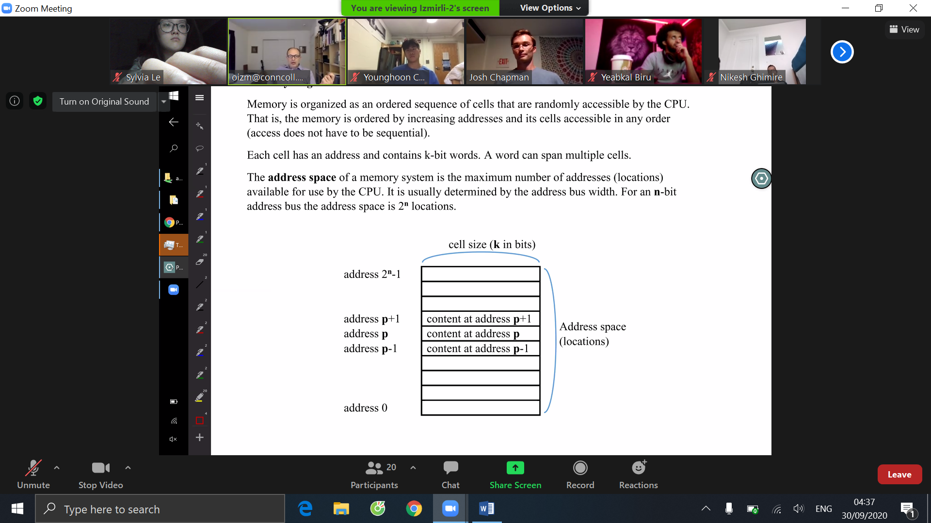

Depends on computer families, how bytes in a word can be read may be different. Big-endian computers read the bytes from left to right, or from the high-order end. The most significant bit is the lowest address. In contrast, little-endian computers read the bytes from right to left or from the low-order end.

Due to external factors, memories can be faulty, hence the need for a mechanism to effectively detect and correct errors. Here we went into correcting single-bit errors. Each memory word is added extra bits so that when that word is read out of the memory, these extra bits are checked to see if an error has occurred. Our convention here is: an n-bit memory word (or codewords) will be made of m data bits and r redundant bits. Given these basic ideas, we went on to discuss the Hamming algorithm to correct single-bit error for any size codewords. Using the above convention, r parity bits are added to the m-bit word to create a new word of length m+r bits. Bits in this new word are numbered starting from 1, with the leftmost bit is numbered 1. All the bits whose bit index number that are 2x are parity bits, the rest are data bits. Each parity bit checked specific bit positions. We assume even parity, which means the parity bit will take the value of 0 if the number of check bits that have the value of 1 is an even number. For a data bit b, it will be checked by those bits b1, b2, ..., bj such that b1 + b2 + ... + bi = b. A more convenient way to add and check parity bits is to use the Hamming code table. An example table used for encoding 16 data bits is shown below. Hamming algorithm is simple yet powerful for single-bit error; however, the efficiency will significantly drop if more than one error occurs.

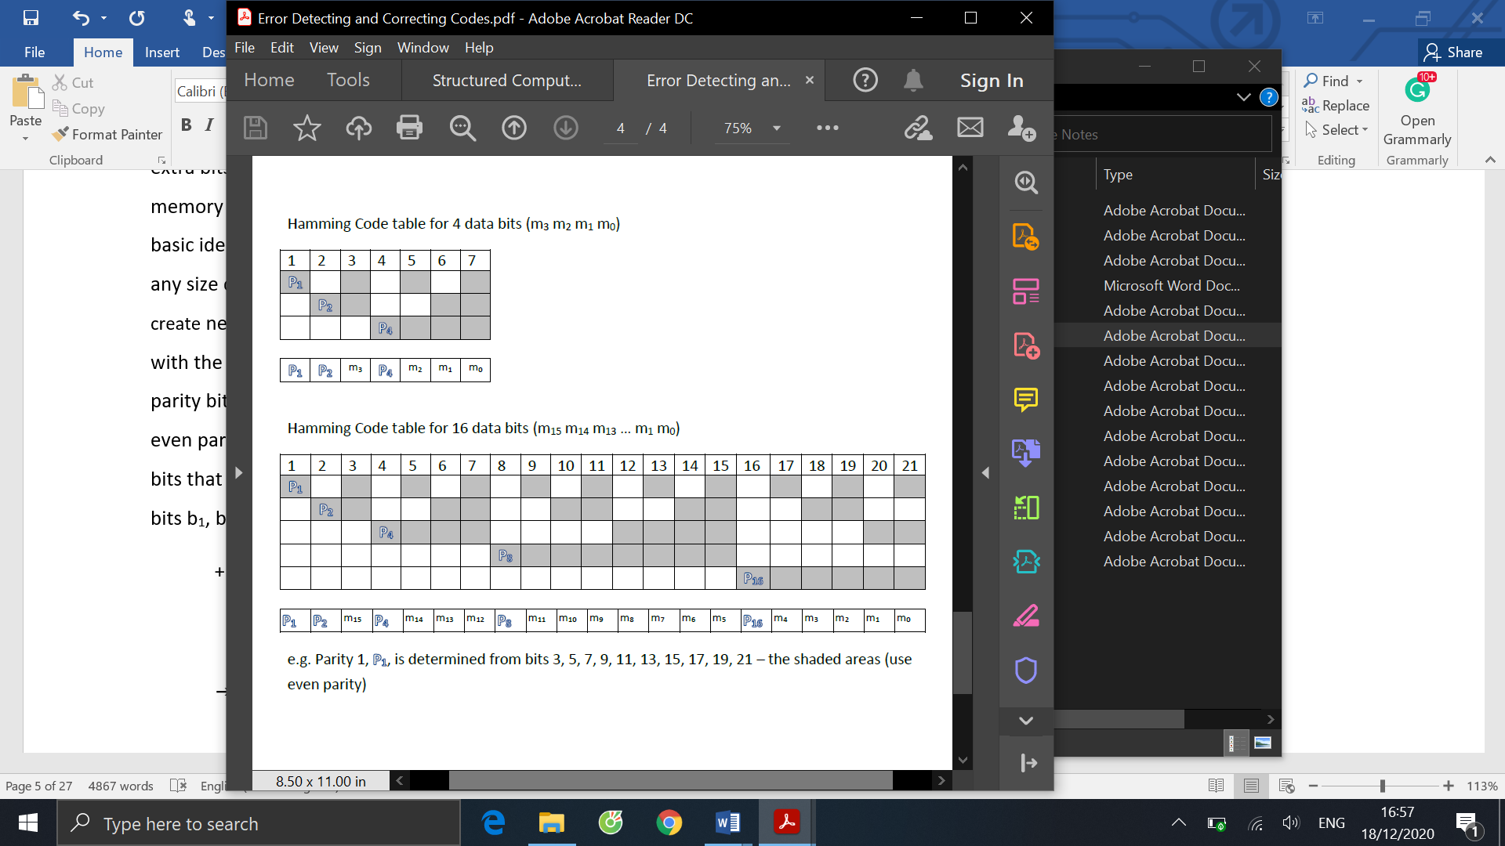

Memories are slow. CPU typically has to wait for several cycles after issuing a memory request to get what it wants. To avoid the need for waiting, cache is invented. The idea is to have a cache to keep the most heavily used or the upcoming memory words. CPU will look up the cache first when it needs a word; if the word is not found then it will turn to look at the main memory. If a substantial fraction of the words are in the cache, average access time can be greatly reduced. A cache miss is when the CPU cannot find what it needs in cache. On some systems, the memory reference can be started in parallel with the cache search, so that if a cache miss occurs, the memory cycle has already been started. When a cache miss occurs, the entire cache line is loaded from the main memory into the cache for convenience. In this section, we learned to calculate the mean memory access time. Suppose c is cache access time, m is the memory access time, h is the hit ratio – the fraction of all memory references that can be satisfied out of the cache. The miss ratio will be calculated as 1 – h. From which, we have the mean memory access time equals c + (1-h)m.

After being equipped with the general concepts, we were ready to examine the digital logic level. Digital circuits can be constructed from a small number of primitive elements by combining them in numerous ways. A digital circuit is one in which only two logical values are present. From 0 to 0.5 volt is a value, typically binary value 0. From 1 to 1.5 volt is a value, typically binary value 1. Any value outside the two ranges is not permitted. To calculate various functions of these two valued signals, small electronic devices called gates are used. They are the hardware basis of all digital computers. The basic gates are AND, OR, NOT, NAND and NOR. The sign for each gate and their behavior is described in the following figure. NOT, or sometimes called an inverter, is the only gate that takes one input and outputs its complements. Other gates can take two or more inputs (although often not over 8). The table rows show possible input combinations and their corresponding output. As shown, NAND gate is the reverse of AND gate, and NOR gate is the reverse of OR gate.

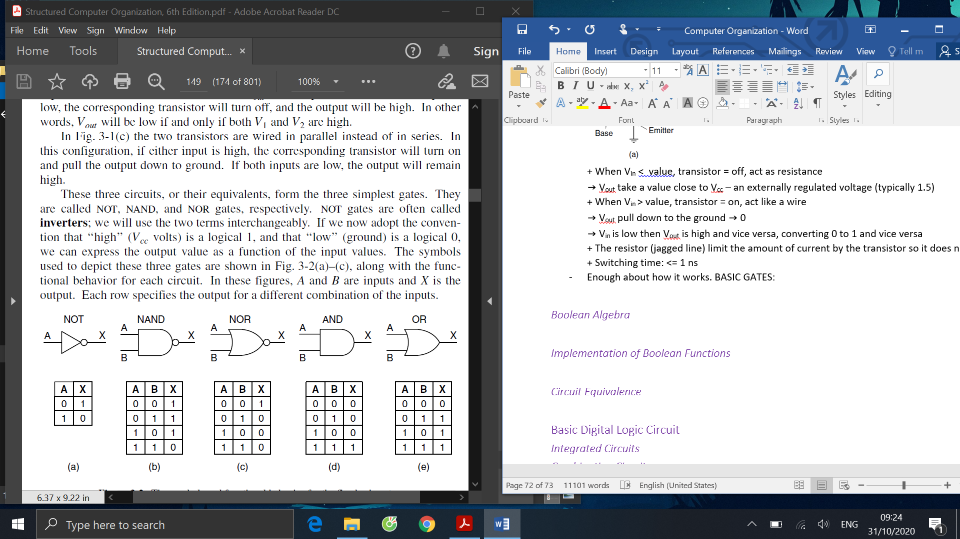

Now that we have the gates, we can combine them to make circuits. To describe these circuits where input can only take either 0 or 1, Boolean algebra is needed. A Boolean function of n variables can only have 2n possible combinations of input values, therefore it’s possible to describe such a function using truth table: a table with 2n rows, each row is a different combination of input values. However, as the number of inputs increase, the number of rows grows exponentially, making the table cumbersome. This gives rise to another notation, where only the combination of input that gives the output 1 is written out. Arithmetic signs are used to represent Boolean function: ‘+’ sign is OR and ‘.’ Or multiply sign is AND. A bar on top of a character or a single quote next to a character means that its value is inverted and equal to 0.

Given the possible inputs and its output, we have been able to construct a Boolean function. This function can now be used to implement the actual circuit by following these steps. First, write down the truth table for the function. Then we provide inverters to generate the complement of each input. Afterward, draw an AND gate for each term with a 1 in the result column and wire the AND gates to the appropriate inputs. Finally, put the outputs of all the AND gates into an OR gate. Before implementing a circuit, Boolean functions can be simplified by applying Boolean algebra laws to reduce the number of gates and chip area needed. This helps greatly reduce power consumption and increase computation speed. The common laws that are used are as follows:

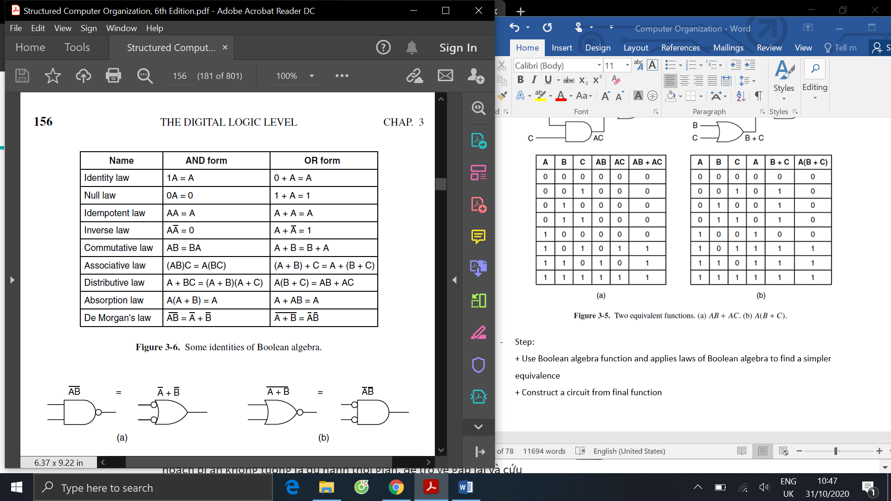

We are fully equipped to build more complex circuits. In the next section, we discussed combinational circuits, where there are multiple inputs and outputs and outputs values are uniquely determined by current input values. The first combinational circuit that is examined is the multiplexer. It’s a circuit with 2n data inputs, one data output, and n control inputs that select one of the data inputs. The selected input is sent to the output. The 8 input multiplexer circuit is depicted in the figure. Each AND gate is enabled by a different combination of the control inputs. Three control lines A, B, C will select one of the 8 input lines is sent to the OR gate, then to the output. No matter what is on the control lines, seven of the AND gates will always output 0, the remaining gate’s value depends on the value of the selected input line.

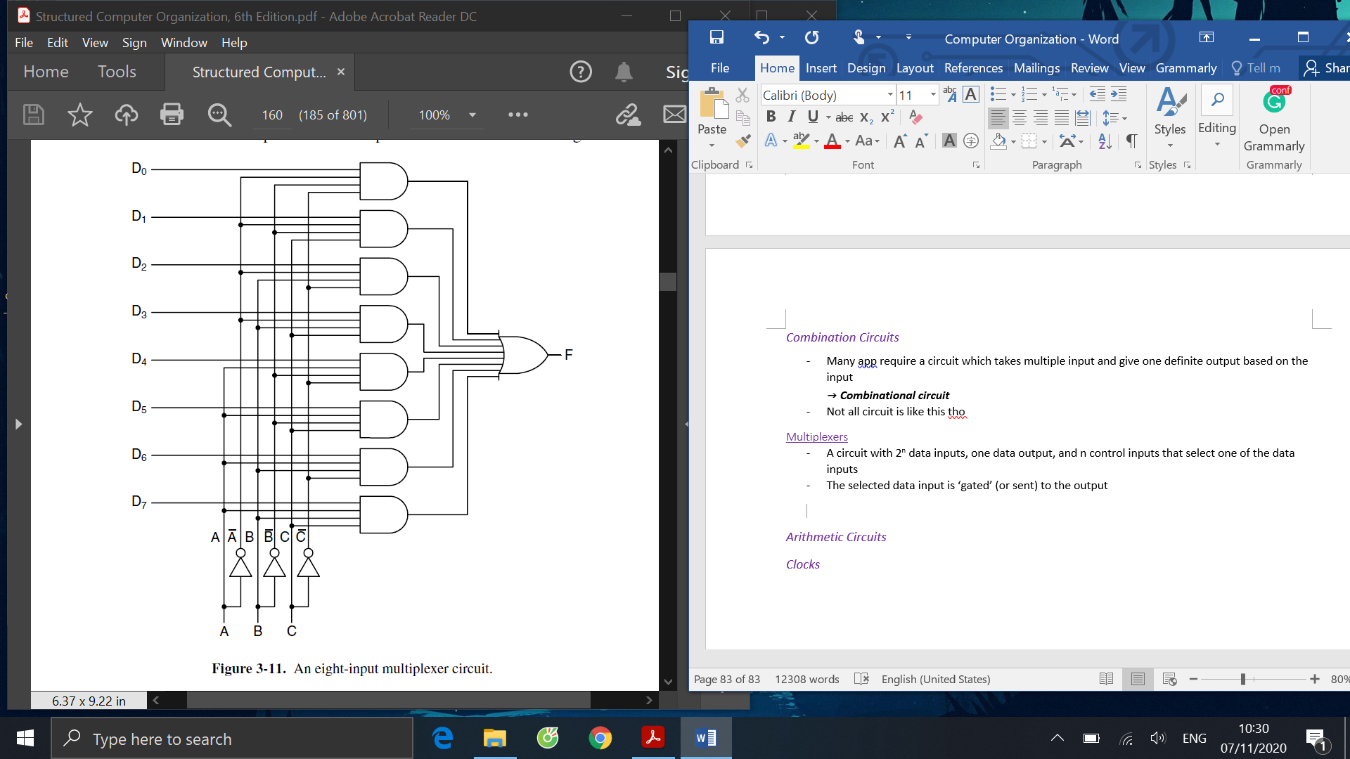

Another combinational circuit is the decoder. It takes an n-bit number as input and uses it to select exactly one of the 2n output lines by setting its value to 1. The circuit for the decoder is below. Given n input, each of the 2n inputs combinations will result in exactly one output set to 1 and all other output lines will be 0. This circuit is useful to select one particular function or component, as we later discussed the ALU and the memory chip.

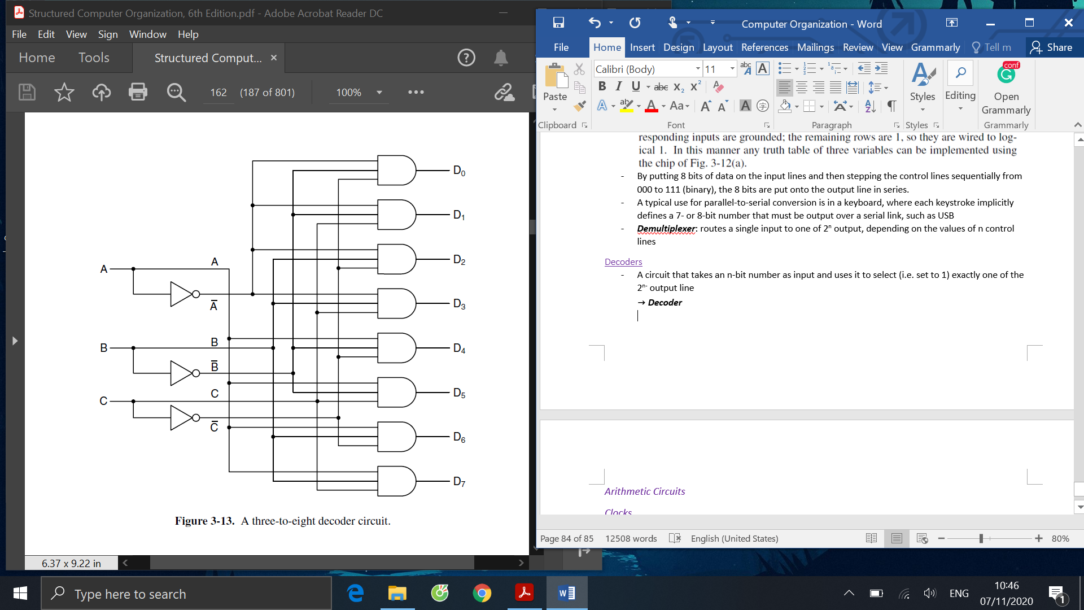

Using combinational circuits, we can build more complex arithmetic circuits and eventually the ALU. As a prelude, a shifter is a combinational circuit that shifts the position of all bits of the input number. Using multiplexers, we can design a more capable shifter that not only supports shifting the bits left/right but also include the option of copying the input without shifting it. The figure below shows how four 4x1 multiplexers can be wired together to become a 4-bit shifter. Two control lines connect to the four multiplexers and decide what will the entire shifter do base on each of the input combinations of these lines. If both of the lines take value 0 then the shifter will not shift the input. If control line C1 takes 1 and C0 takes 0, the shifter shift the bits left 1 bit. If both control lines take 1, the shifter will shift the bits right 1 bit. Another control line and two 2x1 multiplexers can be added to add the rotate function.

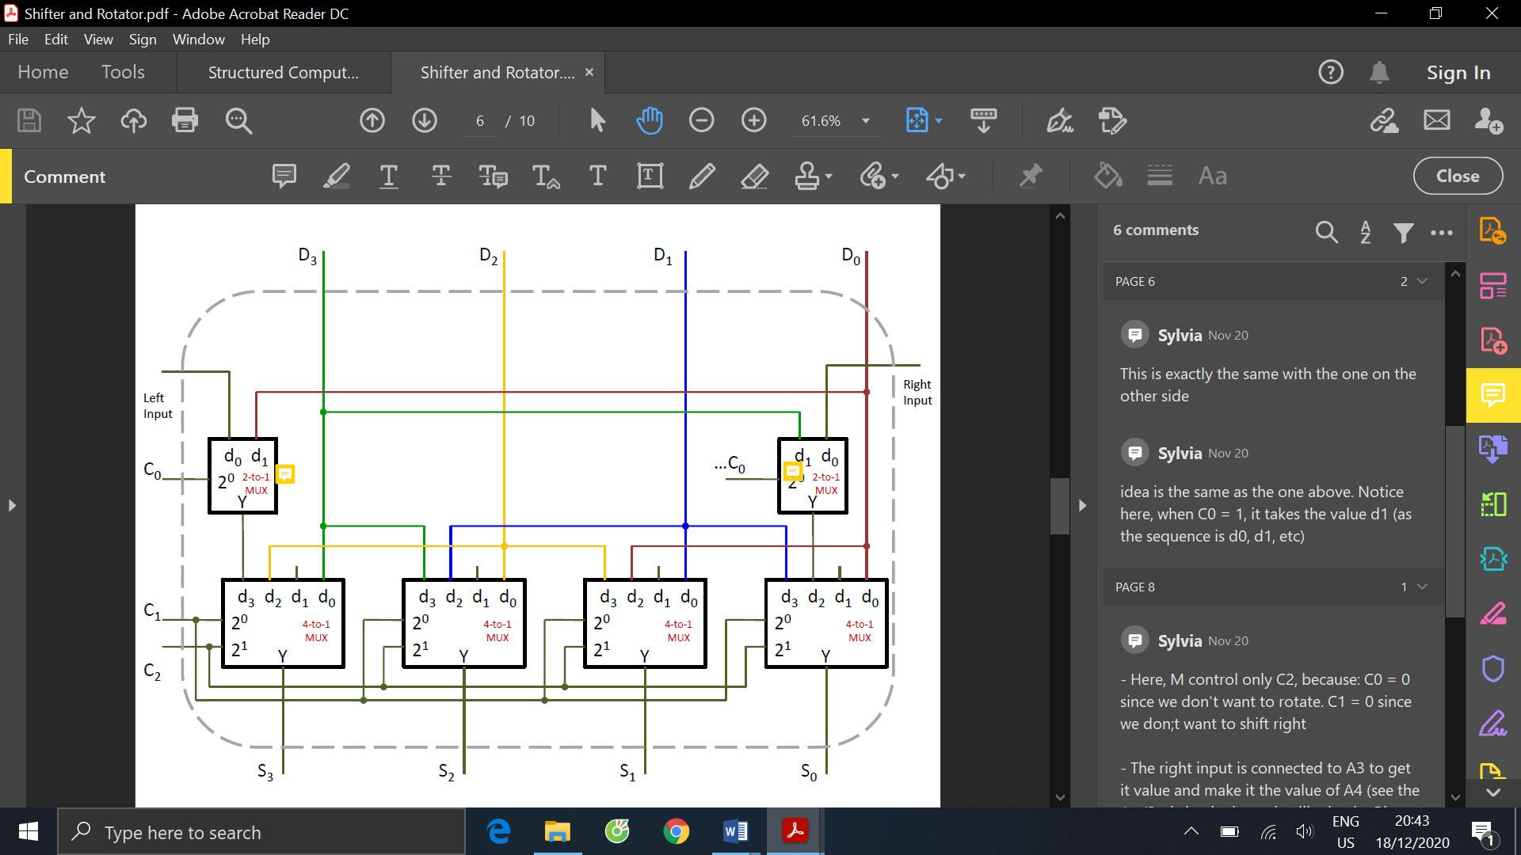

We are ready to move on to a circuit that is essential to any CPU – one that performs addition. We first build a half adder, which take two binary input, produce the sum and the carry on. The figure below provides the truth table for this simple 1-bit addition, and following the rules described above, we have the corresponding circuit.

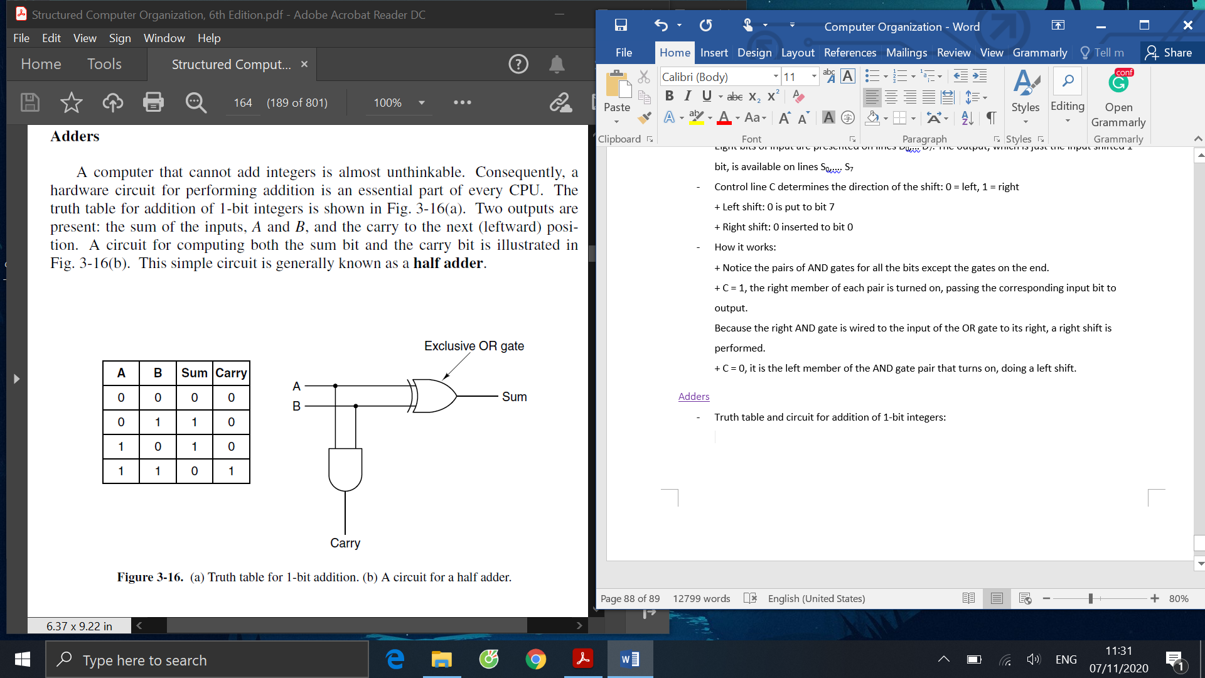

From the half adder, we can add another one and make it a full adder, which can handle the carry into from the position on the right, as depicted below. Now that we have the 1-bit full adder, we can connect to each other, with the carry out of the bits to the right provide the carry into the bits to the left. The right-most bit’s carry in is wired to 0.

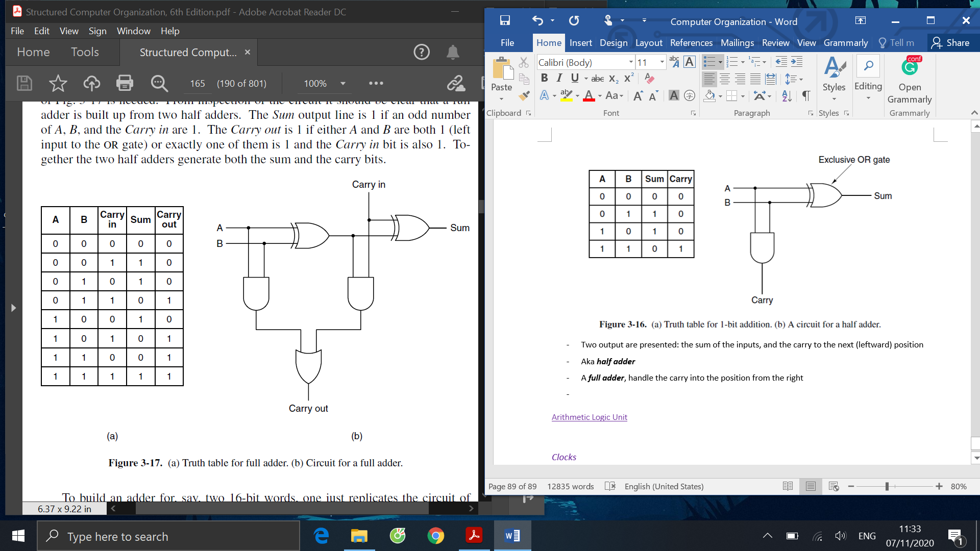

We now have all the components needed to build the 1-bit ALU, as drawn in the figure below. The described ALU can compute any of these four functions: A AND B, A OR B, B’, A + B (in the normal arithmetic sense). On the lower left hand is a 2-bit decoder use control signals F0 and F1 to choose one of the operations to carry out. The upper left hand has the logic gates to compute A AND B, A OR B, and B’s complement. Under normal conditions, ENA and ENB are both 1 to enable both inputs and INVA is 0. The lower right-hand corner has a full adder for computing the sum of A and B, including handling the carries. These 1-bit slices can be connected to provide a word ALU, such as an 8-bit ALU as depicted subsequently.

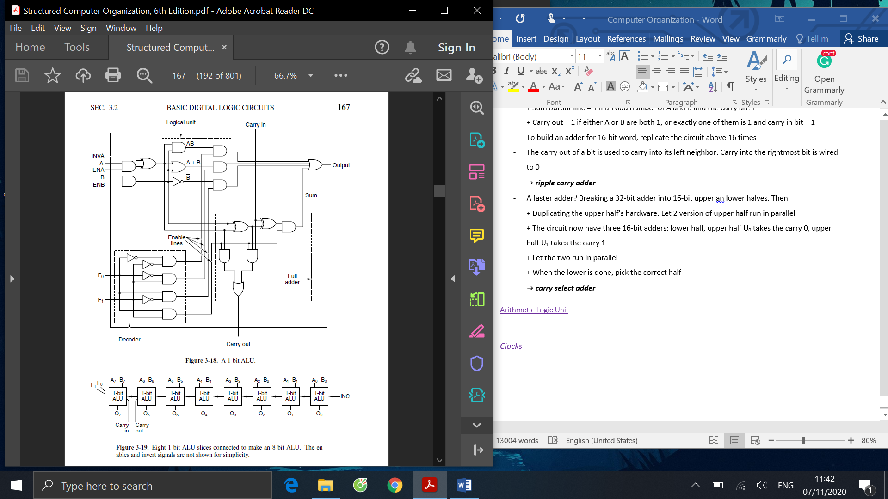

Compare what we currently have with the simplified model of the data path above, we now only need to implement a circuit to be our memories, then we are ready to build the data path, and eventually the Mic-1 microprocessor. In memory circuits, we first discussed latch, the 1-bit circuit that sort of ‘remembers’ previous input. It’s built from 2 NOR gates, with 2 inputs: S for setting the latch, and R for resetting the latch, and 2 outputs: Q and its complement. It’s worth noting that the output of the latch is not uniquely determined by current inputs. Latch can have consistent state: state 0 (when Q = 0) and state 1 (when Q = 1). When Q is 0, setting the latch (by setting S to 1) change the state of the latch from 0 to 1. When Q is 1, resetting the latch (by setting R to 1) change the state of the latch from 1 to 0.

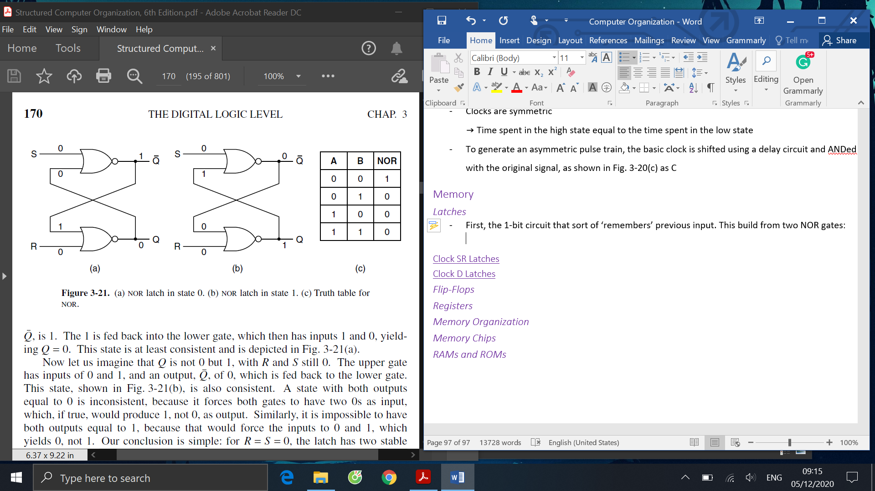

To prevent the latch from changing its value when not required, it can be connected to a clock. When the clock is 0, the latch simply ignores the value of S and R and remains unchanged. When it’s 1, the latch now sensitive to the S and R input. However, there is another problem, which is if the value of S and R are both 0, the latch’s state is unstable. This is resolved by using a Clock D latch, where there is only one input given, but it will branch and go through an inverter. This makes the two ‘inputs’ cannot have the same value. When the clock is 1, D is 0 will drive the state of the latch 0, and D is 1 will drive the state of the latch 1. Or, we can say, the value of D is sampled and stored on the latch, making it now a true 1-bit memory. The value stored is always available at Q. To load the value of D to the latch, we just need to set the clock to 1

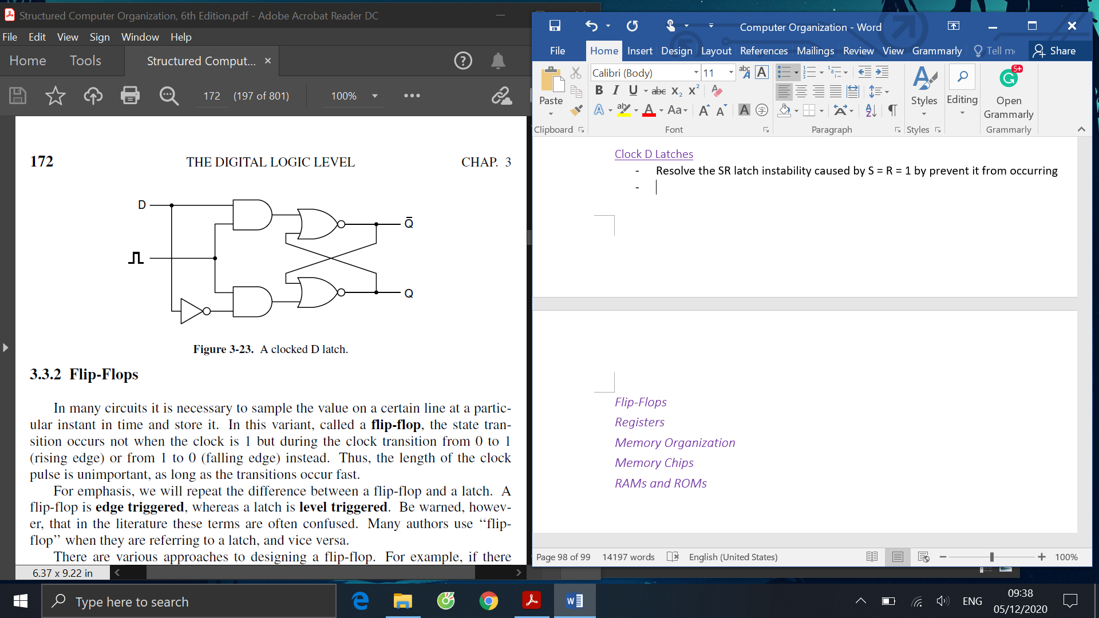

There are times when it’s necessary to store a value at a certain instant in time. A circuit that can do this is called the flip-flops. In flip-flops, the state transition occurs not when the clock is 1 but during the clock transition from 0 to 1 (rising edge) or from 1 to 0 (falling edge) instead. Hence, the length of the clock pulse is unimportant, as long as the transitions occur fast. To distinguish from latch, remember flip-flop is edge-triggered, a latch is level triggered. A flip-flop can be designed by generating a very short pulse on the rising edge of the clock signal, that pulse could then be fed into a D latch. This D latch will be activated at a fixed delay after the rising edge of the clock.

Given the basics of latches and flip-flops, we can now build a memory that can address individual words. The following figure shows memory with four 3-bit words. It has a total of 8 input lines: Three data inputs – I0, I1, I2; two address lines – A0, A1; Three for control - CS for Chip Select, RD for distinguishing read and write, and OE for Output Enable. Three output lines are available: O0, O1, O2. To select a memory block, CS is set to 1. RD is set to 1 for reading and 0 for write. The address lines made up a decoder that will be responsible for choosing which word to be read or written

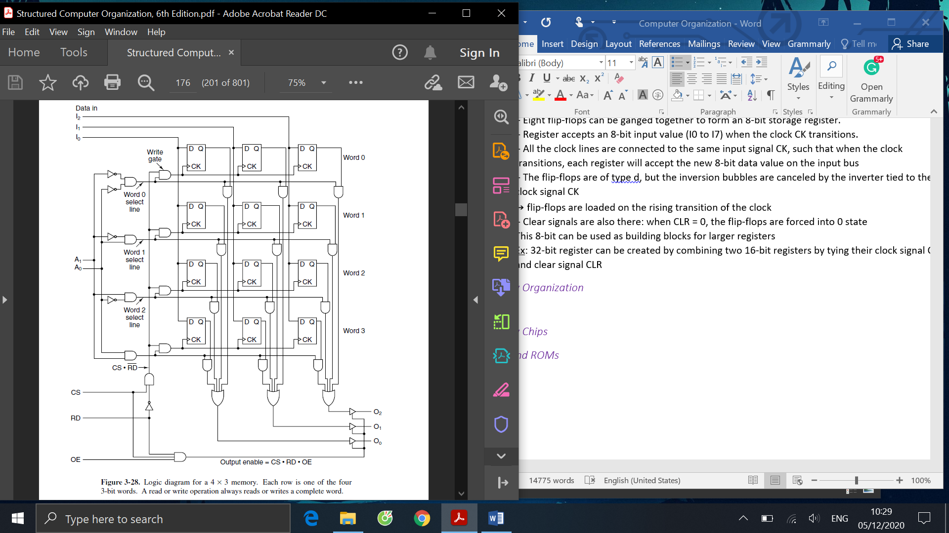

To perform write, the decoder first selects the word to be written. The CS control line is set to 1 (to choose the memory chip), the RD control line is set to 0 (to signify write). RD signal is put through an inverter, before going through an AND gate together with the CS control line. The output of this AND gate will the wired to 4 other AND gates that take the result of the decoder as its second input. This will enable the clock signal for the word chosen, allow loading the input data to the flip-flops. The way read is performed is quite similar to write, just that all the write gates are disabled. The word select line enables the AND gates tied to the bits of the selected word. The selected word outputs its bits into the OR gates at the bottom. The outputs are 0 for not selected words.

It’s also simple to make a bigger memory chip using this design. For example, to make a 4x8 chip (4 words of 8-bits each), we need to add 5 more columns of four flip flops each, 5 more input lines, and 5 more output lines. To make an 8x3 chip (8 words of 3-bits each), we add 4 more rows of 3 flip flops each and another address line A2. The number of words should be a power of 2, but the number of bits in a word can be anything

We are now ready to build the data path, the part of the CPU that has the ALU, inputs, and its outputs. The model of the ALU we are going to discuss is in Fig. 4-1. In this design, most registers are 32-bit, and most can load the B bus. Output of ALU can drive the C bus, which will load the register with its data when it’s the right time. It’s important to remember that it may be desirable to write what on C bus to more than 1 register, but to load multiple registers on B bus is not. ALU functions are controlled by 6 control lines: F0 and F1, ENA and ENB, INVA and INC (to force a carry into the lower order bit). ALU can take 2 inputs: the left input from the holding register, the right input is loaded from any of the nine register sources. The MAR/MDR combination is used to read and write ISA-level data. MAR contains address of word (word 0, word 1, . . .) to be read into MDR. PC/MBR combination, on the other hand, is used to read the executable ISA-level program, which consists of a byte stream. PC contains addresses of byte (byte 0, byte 1, . . . ) to be read into low-order 8 bits of MBR.

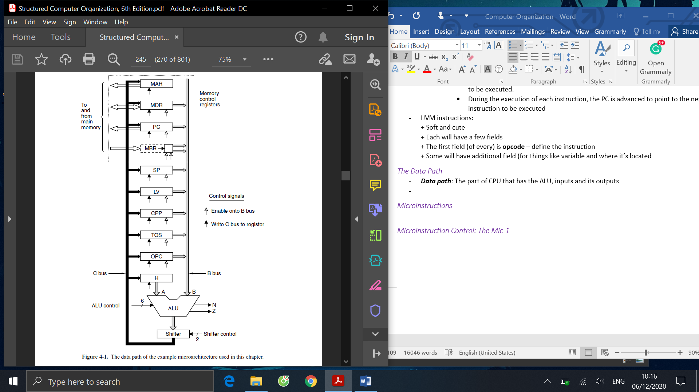

The timing of what happens in a data path cycle is described in the graph below. A short pulse is produced at the start of each clock cycle. On the falling edge of this pulse, the bits that will drive all the gates are set up. This takes a time of Δw. The register needed on the B bus is selected and driven onto the B bus, which takes Δx for value to be stable. The ALU and shifter, which as combinational circuits have been running continuously, finally have valid data to operate on. This process takes Δy for the final output to be stable. After an additional Δz, the results have propagated along the C bus to the registers, where they can be loaded on the rising edge of the next pulse. Time interval after z provide some tolerance, in case there are problems occur. The load should be edge-triggered and fast, such that even if some of the input registers are changed, the effects will not be felt on the C bus until long after the registers have been loaded. Also, on the rising edge of the pulse, the register that is currently driving the B bus stops in preparation for the next cycle.

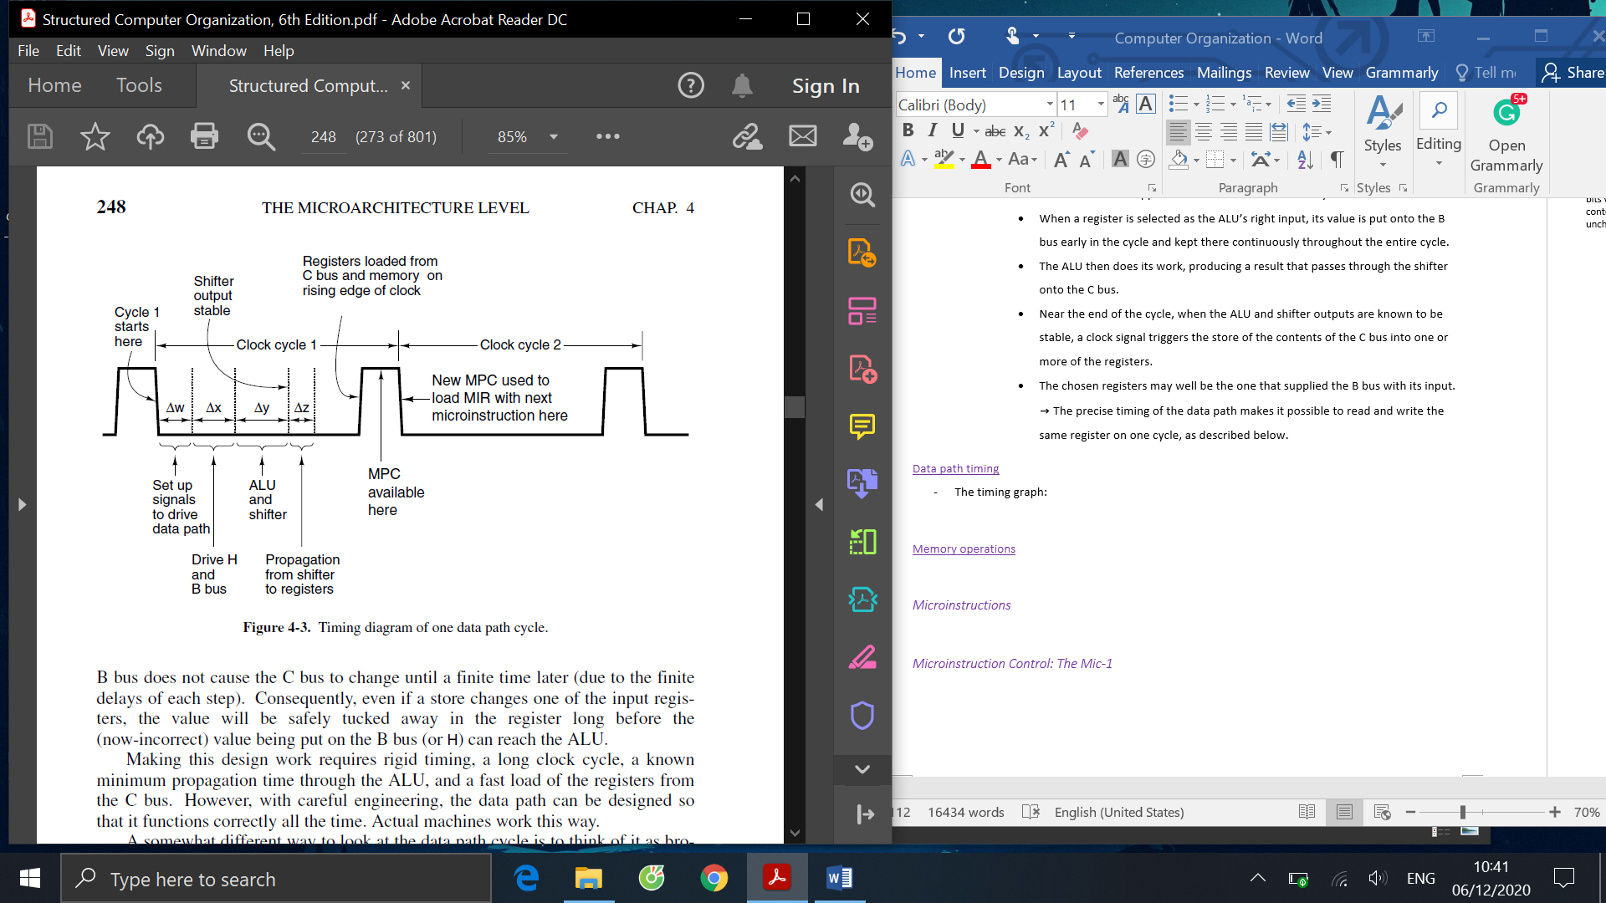

Having understood the data path, we can build a complete microprocessor. The microprocessor has a large and very important item – the control store. It’s the memory that holds the complete microprogram (made of microinstructions instead of ISA instructions). The operations of Mic-1 are as follows: first, at the start of each clock cycle (the falling edge of the clock), MIR is loaded from the word in the control store, pointed to by MPC. The loading time is Δw (first subcycle). After the microinstruction is set up, signals propagate out into the data path. ALU inputs are stable after Δw + Δx from the start of the cycle (second subcycle). ALU then does the calculation. Its output, N and Z, and shifter outputs are stable after Δy later. The N and Z values are then saved in a pair of 1-bit flip-flops, on the rising edge near the end of a clock cycle (third subcycle). The shifter output has reached the registers via the C bus, after Δz interval. Registers and N and Z flip-flops can be loaded near the end of the cycle. This process terminates just a little after the rising edge of the clock when results have been saved, the result of previous memory operation are available, and MPC has been loaded (fourth cycle). This entire procedure goes on until the user turn the machine off

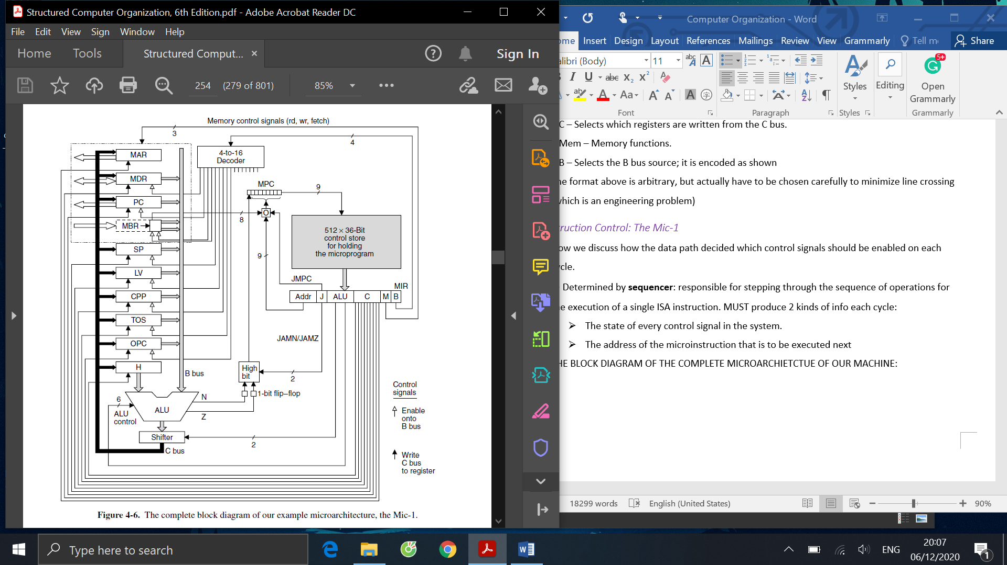

Signals that control the data path can be grouped into six groups, including bits that responsible for determining the next instruction. Together they made up the microinstruction format below. Here, the Addr field contains the address of a potential next microinstruction. JAM determines how the next microinstruction is selected. ALU field controls ALU and shifter functions. C selects which registers are written from the C bus. Mem field decides the memory functions. B field selects the source for the B bus.

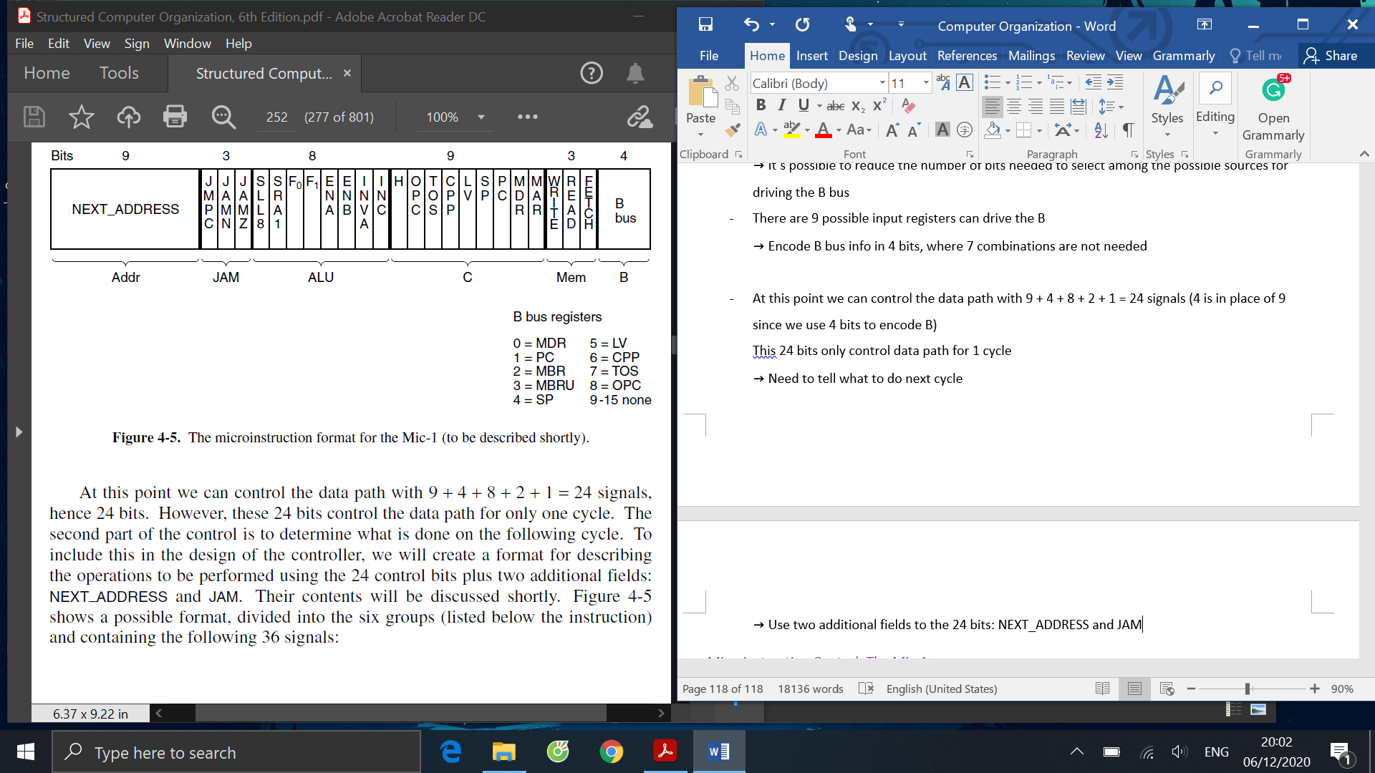

As mentioned, the Addr and JAM field works together to determine the next instruction to be executed. When it’s time to determine what is the next instruction, NEXT_ADDRESS is copied to the MPC, then JAM is inspected. The value of JAM will determine what is the final next instruction. If JAM’s value is 000, then the next instruction to be executed is located NEXT_ADDRESS. If bit JAMN is 1, the 1-bit N flip-flop is ORed into a high-order bit of MPC. If bit JAMZ is 1, the 1-bit Z flip-flop is ORed into a high-order bit of MPC. If both JAMN and JAMZ is set, both bits are ORed there.

As we now have the complete Mic-1, we can start discussing the ISA level of the machine to be interpreted by the microprogram running on the Mic-1. We first need to understand the concept of stack. It’s an area of memory that is reserved for local variables of procedures. Individual variables don’t get absolute addresses in it

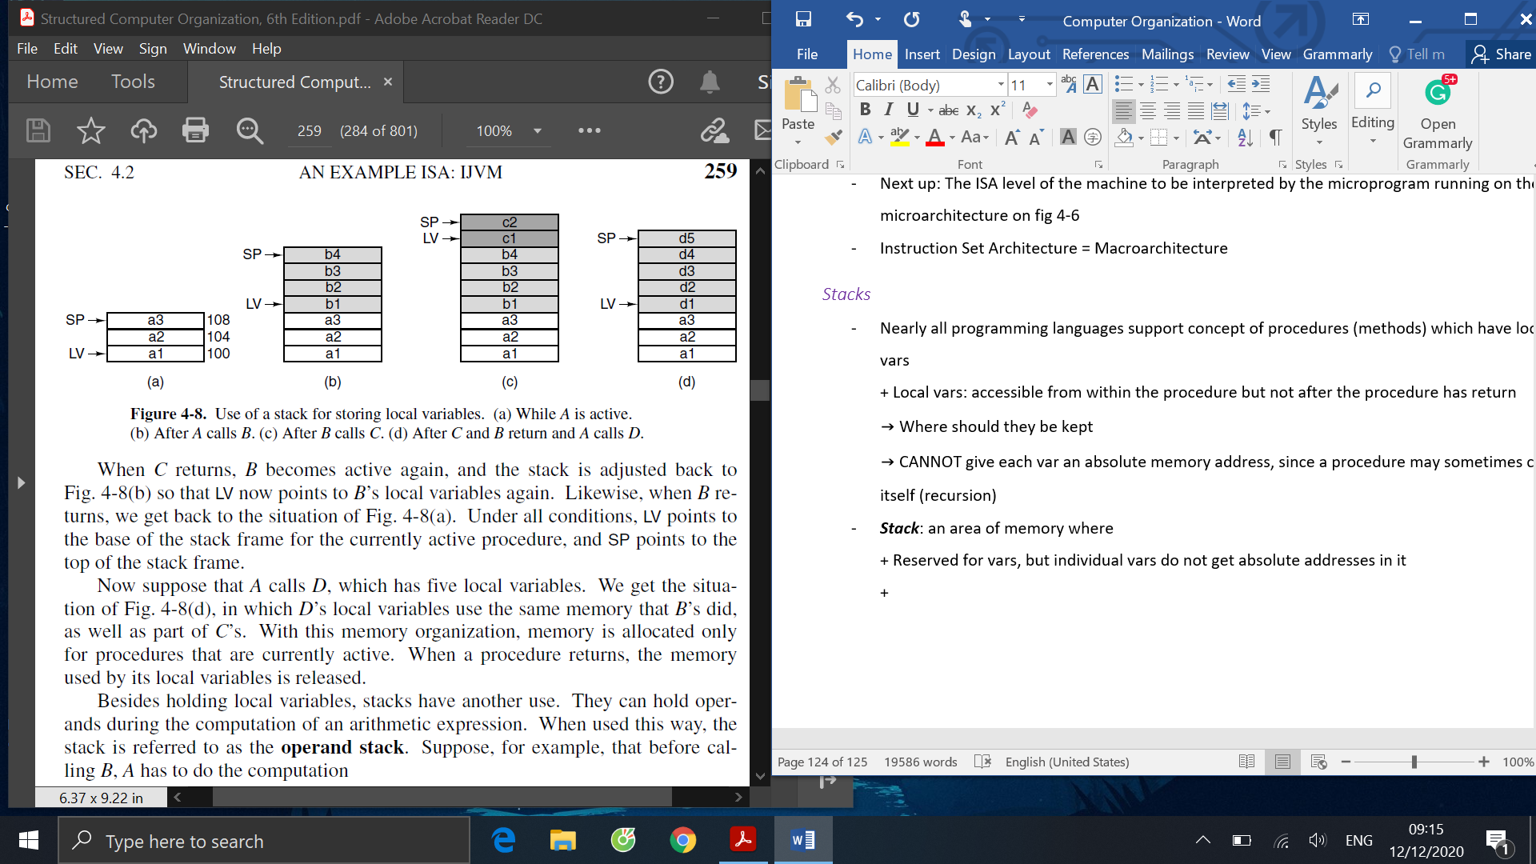

Using the figure above, as an illustration, suppose a procedure A which has local vars a1, a2, a3. LV register is set to point *to the base of the local variables for the current procedure*. SP points to the *highest word* (in terms of address) of A’s local variables. Thus, if A is 100, words are 4 bytes, then SP = 108. Variables in the stack are referred to by giving their distance (offset) from LV. The data structure between LV and SP (including both words) pointed to is called A’s ***local variable frame***. If procedure A now calls another procedure, B with four local vars b1, b2, b3, b4, these four variables will be stored on the stack, right on top of A’s (part b of the figure).LV now points to the local variable of B instead of *A*. B’s other local variables can be referred to by giving their offset from LV

Stacks can also be used to hold operands during the computation of an arithmetic expression. In this case, it’s called the operand stack. If we now suppose procedure A has to calculate a1 = a2 + a3. What happens now is that first, a2 will be pushed onto the stack. SP is now incremented by the number of bytes in a word (in this case, 4). Next, a3 is pushed on to the stack. The actual computation can now be done by popping the two words a2 and a3 off the stack, add them together, and pushes the result back onto the stack (part c of the figure). The top word can be popped off the stack and stored back in a1

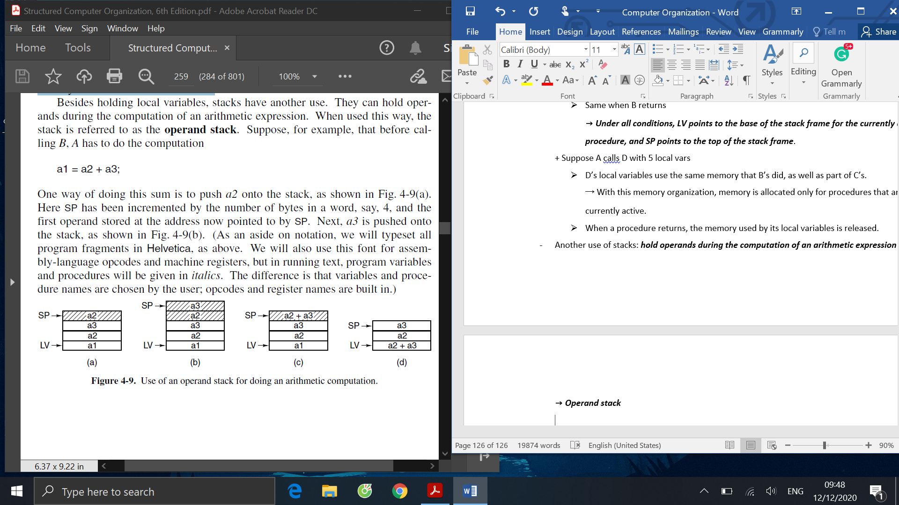

After understanding how stack works and how variables are stored in stack, we are in a comfortable state to write programs in Java assembly language, given a piece of Java code. The Java assembler will then translate the assembly program into the binary program shown in part c of the figure below. The process that happens in the assembly language is explained here. First, j and k are pushed onto the stack and added, the result is stored in I (line 1 to 4). Then, i and the constant 3 are pushed on to the stack and compare (line 5 to 7). If they are equal, a branch is taken to L1, where k is set to 0. If they are unequal, the code following IF_ICMPEQ is executed. Finally, the code will go to L2, where the code outside of the conditional structure continues (not shown in the Java code).

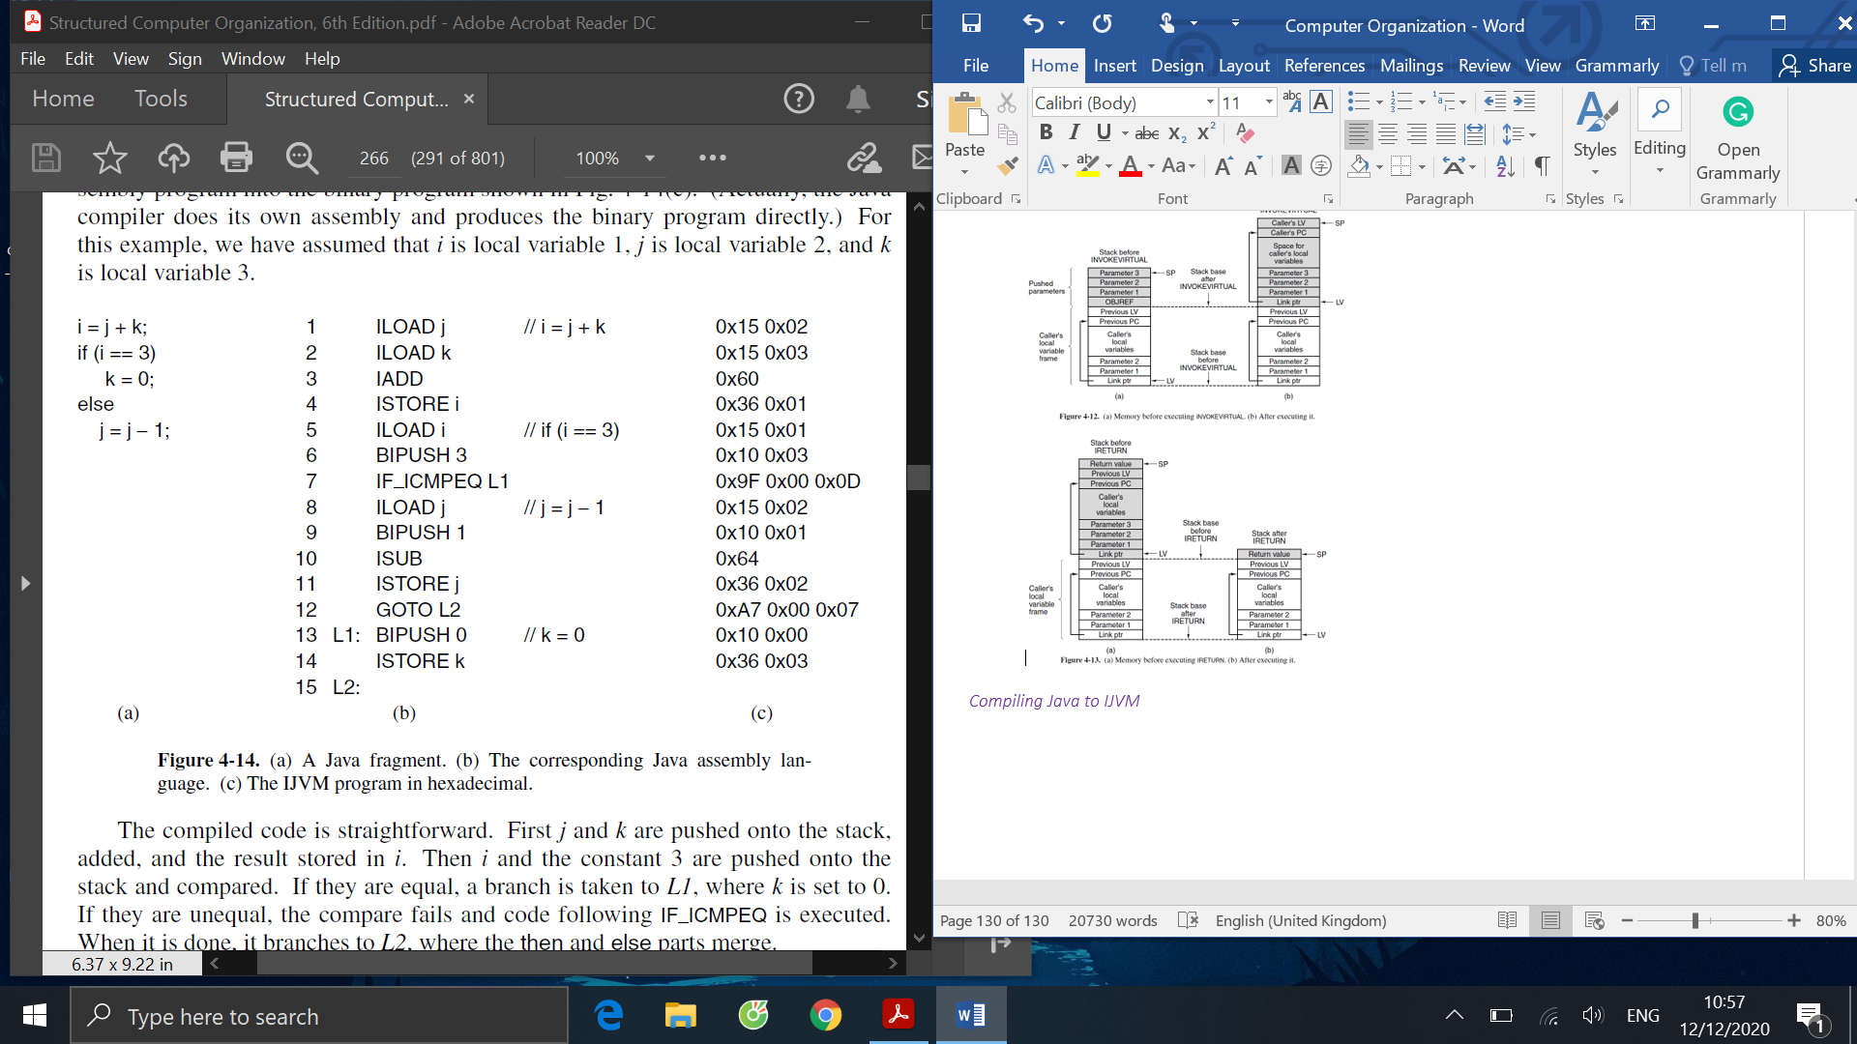

In this course, we have gone through the overview of the multilevel machine model, then look at the basic components of digital computers. We briefly understand how it works, and outline some of the points to keep in mind when we go deeper to design it later. We get to examine how the components are constructed at the hardware level, how all the gates and circuits are combined to create the components we previously mentioned. We eventually get to apply what we learned on designing a data path, and then a simple microprocessor using the structure we created, and finally write a microprogram for it. After this course, I personally feel fairly confident when talking about the structure of computers and hardware related problem.